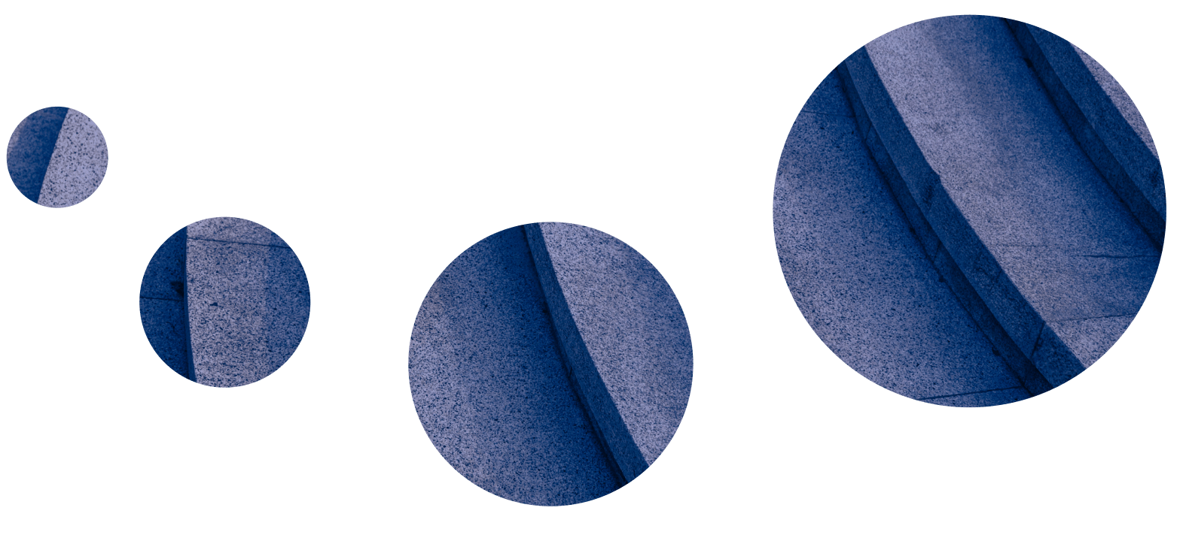

|  |
| --- |
|  |

Games Design Document

Game Name

**Dave Daniel**

**D025959K**

|  |  |
| --- | --- |
|  |  |
|  |
|  |  |

Tables of Contents

Contents

Scripted Sequence documentation: 12

Player Characters, Controls and Abilities 14

Weapons and Pickups 15

Game Conditions 16

Rewards and Progress 17

High Concept:

* One line Introduction

A vampire back from his century of travel finds its castle in ruins and overtaken by trolls, gremlins and giants. Retake you home from these invaders to reclaim your throne as the supreme villain.

* Theme / Environment / Setting

Theme:

Revenge/ Story Telling

Environment:

Ruined Castle/ Dungeon/ Hell/ Hell Castle

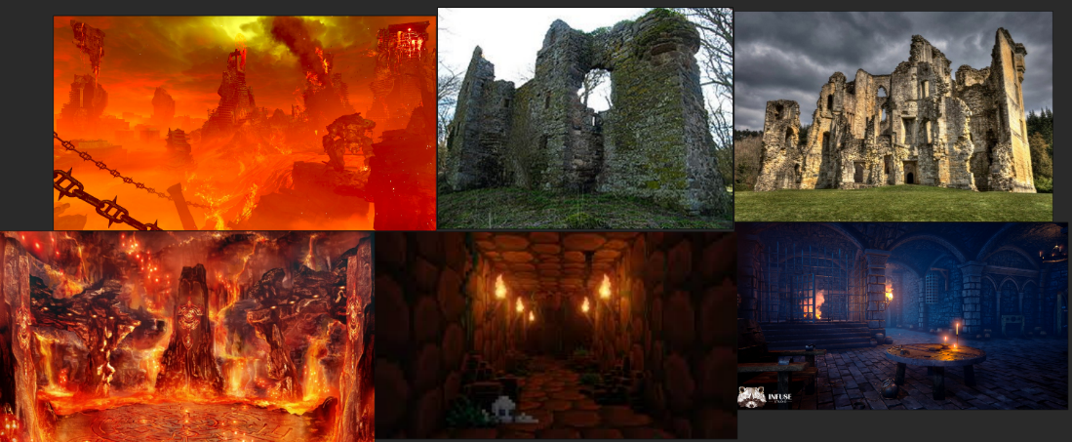

Setting:

Medieval Time/ Pre-Industrial Era

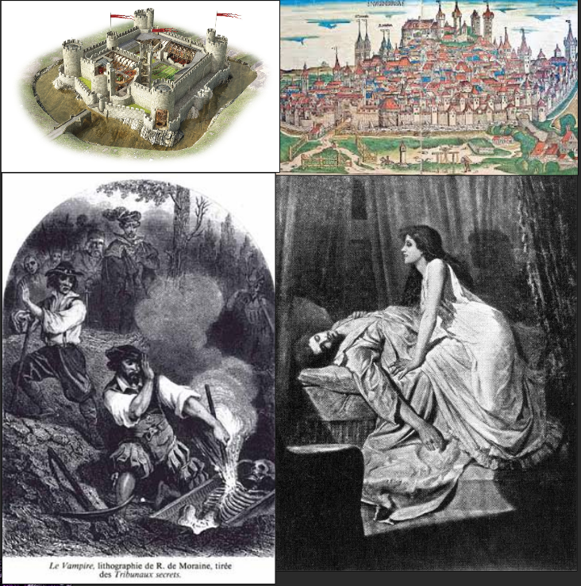

* Unique Selling Point/s and Key Mechanics

Throw your ability to morph your surroundings to get too hard-to-reach areas.

* Enemy Types
* Patrol Enemy
* Bomber
* The skull King
* Frost Giant
* Swamp Troll
* Pickups

Health Pickup

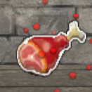

Knife Pickup

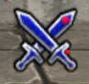

* Weapon Types

Whip:

The player will have a whip that can be used to attack the enemies and damage their surroundings.

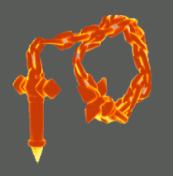

Knife:

Upon deploying the knife not only the player has the option to throw it at enemies to cause damage to them, but also to deploy a wall from the point where the knife hit the wall.

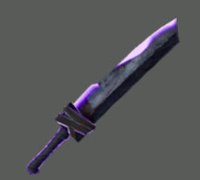

* Player Characteristics Outline

The player character is a vampire who used to be a previous resident of the castle and has decided to come home after wandering around the world.

|  |  |  |
| --- | --- | --- |
| Ability | Purpose | Frequency of Use |
| Wall Knife | Throw knife to a wall and summon a platform | Moderately Used |
| Stun | Use your magic ability to stun enemies | Used where enemies are present |

* Target Audience

The target audience for the game will be of ‘PEGI E.’ It will be aimed to people who enjoy Metroidvanaia games like Ori and the will of the wisp and Hollow Knight, People who also enjoy platformers such as Prince of Persia and Celeste.

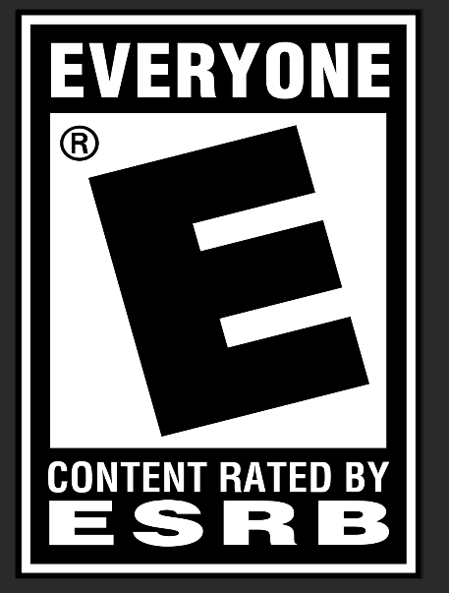

* Market and Competitors

Games like in the genre of Celeste and Hollow knight are the main market for the Metroid Vania genre. The biggest competitors will be these same games published under the same genre.

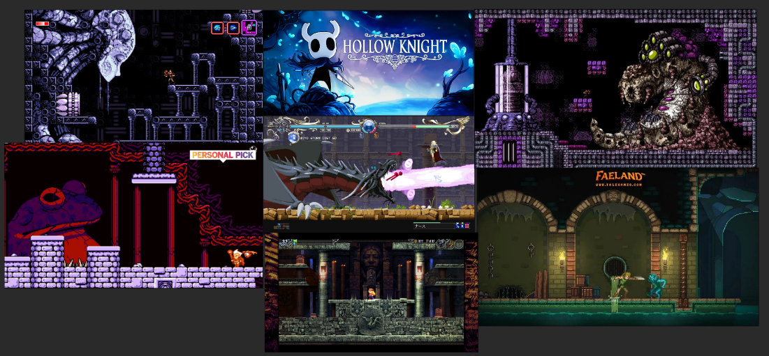

Level Design documentation:

* Goals of level & key areas

The goal of level one is to teach the player how to play the game and what mechanics are available to the player to finish the entire game. The areas highlighted below are teach points where the player learn to interact with the world and complete levels.

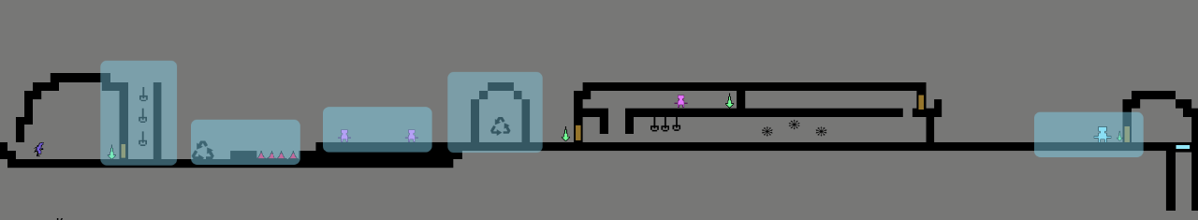

The point of the hell level is to show how deep the enemies have infiltrated to the castle that they have taken control of the castle (Dracul's home). They would essentially learn to use the mechanics they learned in the earlier level to complete this level

The goal of the throne room level is to finish the story of Dracul taking his home back from the invaders currently occupy the castle. The player will face one mini boss and the final bosses in the highlighted zones and on finishing the final boss the cutscene is player for the player.

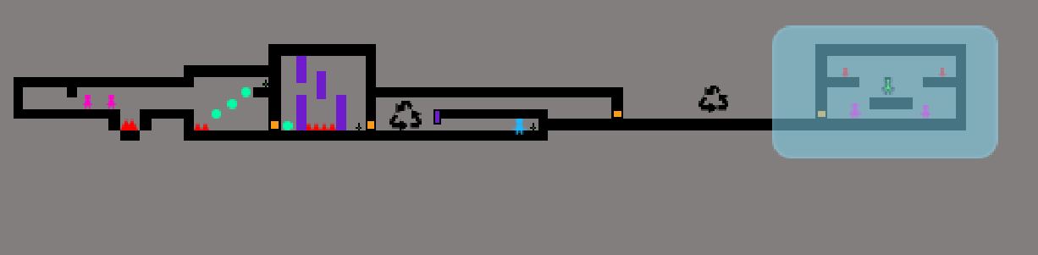

* Story (How, Why, What)

The story takes place after the arrival of Dracul to his castle to find out that it has been taken over by the league member. Dracul must fight his way to the throne of the castle to retake his home back from the invaders

* Focal Point

Macro Focal Point: - Boss Location

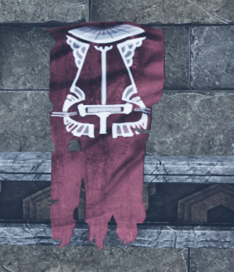

Meso Focal Point: - Rest Location

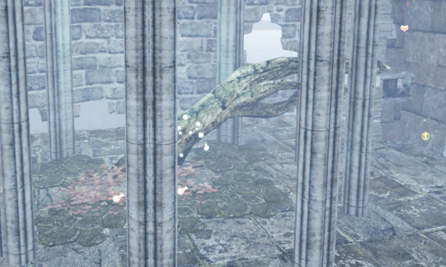

* Visual Development

The map will be in low light and will look gloomy. The grey and dark blue will reflect the medieval era. Some of my influences come from the T.V shows such as ‘Merlin’ and ‘Castlevania’

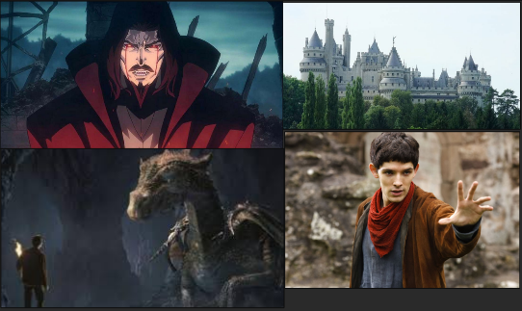

* Gameplay Influences

My main influences for my level are little nightmares and Ori and the will of the wisps. The main USP is influenced from black myth Wu Kong here the player can transform into other animals to get in and out of an area

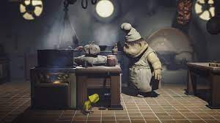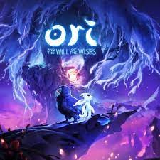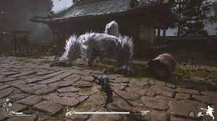

* Colour Palette

The colour palette for the game will be a mix of brown and greys and blues which are provided int the asset packs for the game. The darkness of the overall level will express the darkness that exists in the castle of monsters.

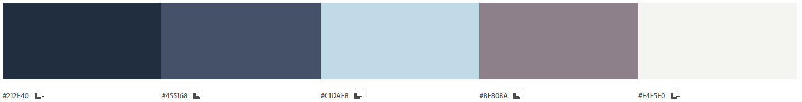

* Lighting

Lighting for this game will be dark and it will reflect on the colour palate decision made to fit the gloomy mood of the game. Lighting for this game will be similar to ‘LIMBO’ as the game does not reflect a happy mood.

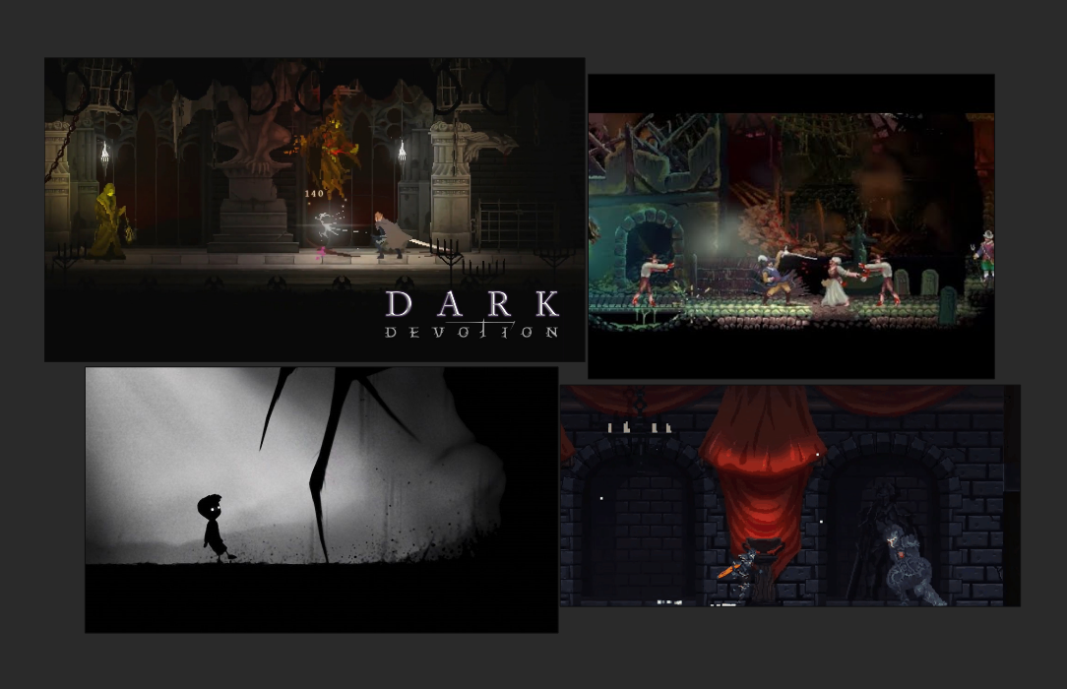

* Asset List

|  |  |  |
| --- | --- | --- |
| Asset Name | Frequency of Use | Source |
| Throne | End Animation | <https://sketchfab.com/3d-models/evil-throne-4cb6a08813374ba1822bc1c37068bf1a> |
| Plains_Floor | Highly Frequent | Framework |
| Rocky_Floor | Highly Frequent | Framework |
| Brigde_wall | Minimal Use | Framework |
| Collundae_Mid | Minimal Use | Framework |
| Cliff_Wall | Moderate use | Framework |
| Pillar | Minimal Use | Framework |
| Angel Statue | Minimal Use | Framework |
| GrimStatue | Minimal Use | Framework |

Level Design Plans

* Focal Point Location

There are two focal points in the map. Each to the where the boss for the map is placed. The macro focal point for the level is and enemy banner to show that the player is near to a level boss where the boss resides.

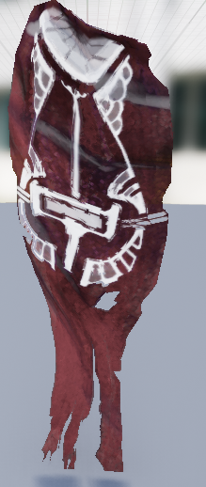

Miso focal points are located within the level in the form of soul trees giving the player a chance to rest and to understand mechanics of the game.

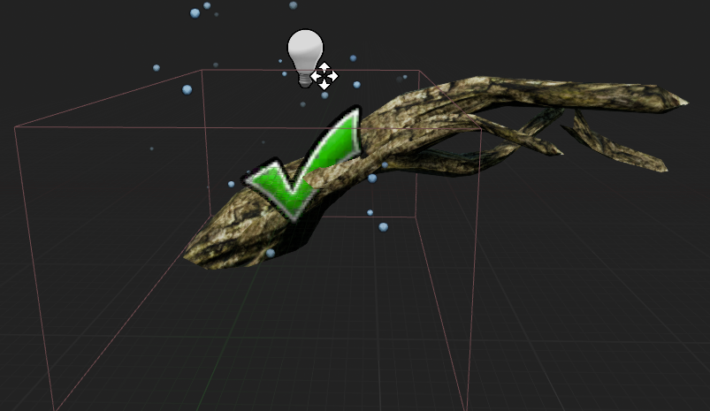

* Focal Point Outlines

The macro focal point for the level is shown in the start of the level in the intro cutscene where the camera pans from the top of the tower to the player where standing. The miso focal points are the soul trees displayed within the map this is where the player can save their game and it will be a respawn point for the player.

* Story Element Locations

The entrance of the castle will indicate the ruined condition of the castle to show that the current residents of the castle have been deteriorating the condition of the castle. The broken condition of the castle will show how

* Critical Path Analysis

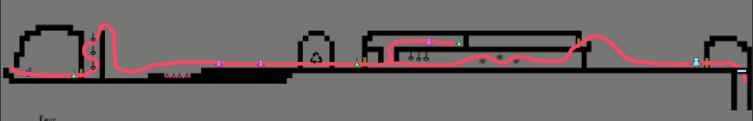Level: Entrance

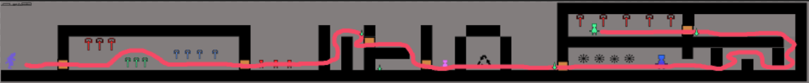Level: Hell

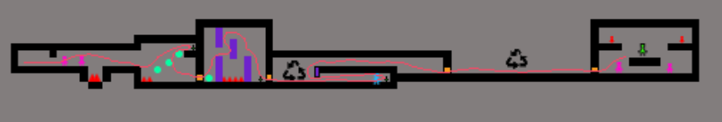Level: Throne

* Enemy Locations

Enemies will be situated closer to where the bosses are situated in the map to give the player time to adjust from the platformer mindset to the action mindset. They will be used as affordances to show that they are approaching closer to the boss of the current part of the map.

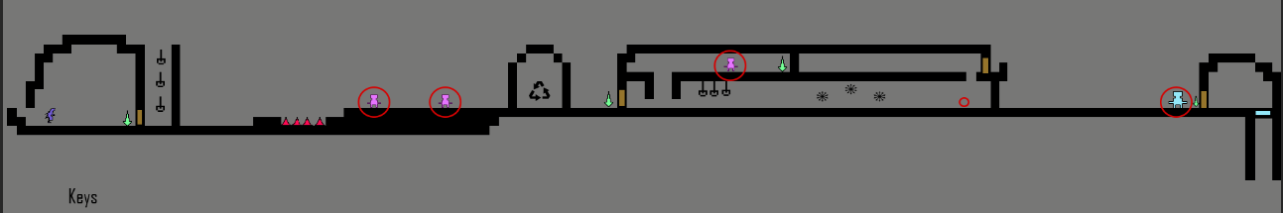

Entrance

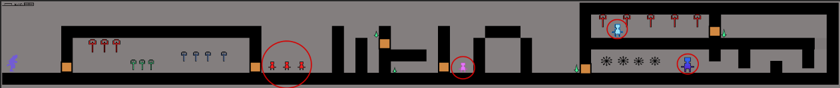Hell

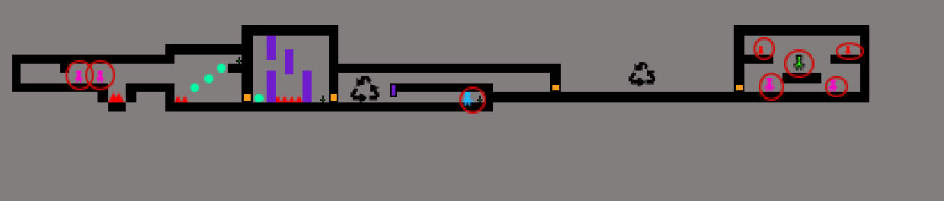Throne Room

* Pickup Locations

Pickups will be located sparsely where the player will have to use their ability. The heart will be located where the player must climb the walls using the knife ability. Health pickups will be located at the rest/Save spots for the player to relax and gain back some HP.

* Level Start & Level End Location

Start Level

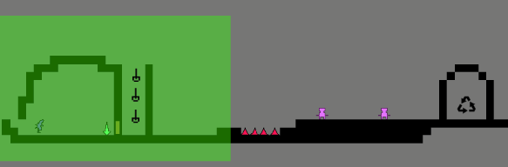

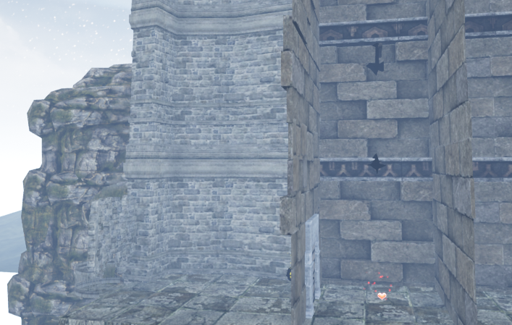

Level One Entrance

Level End

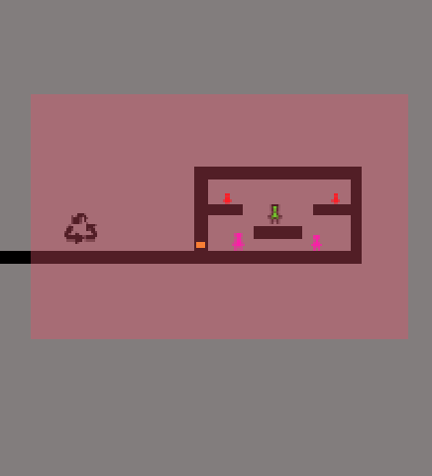

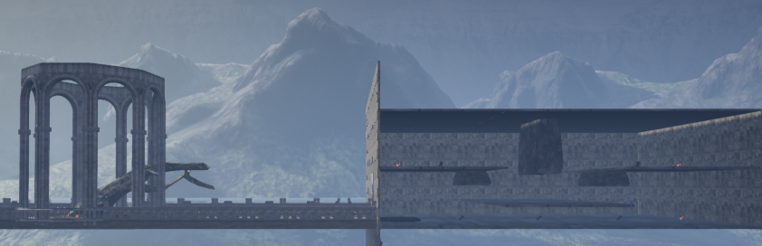Boss Section

* Level flow

Tutorial Sequence

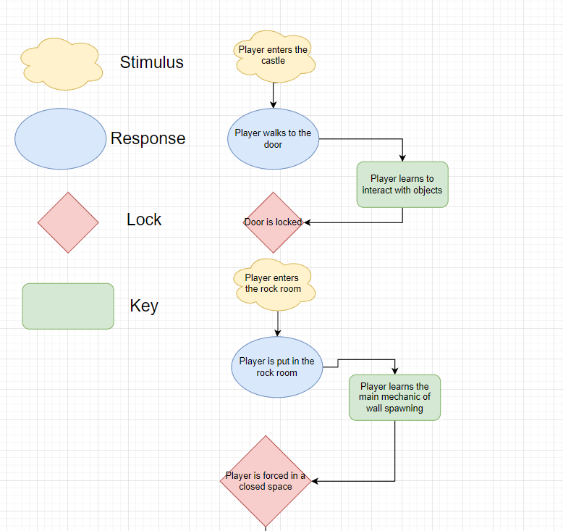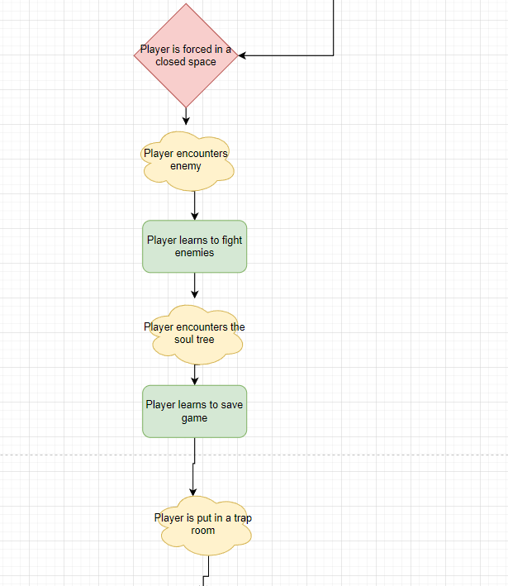

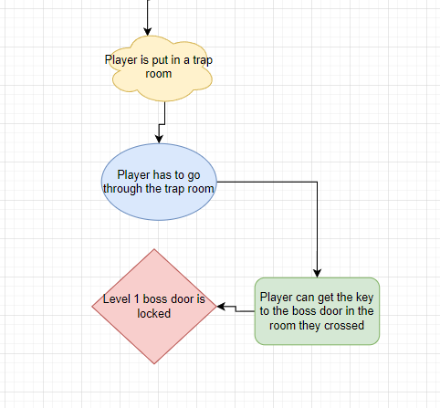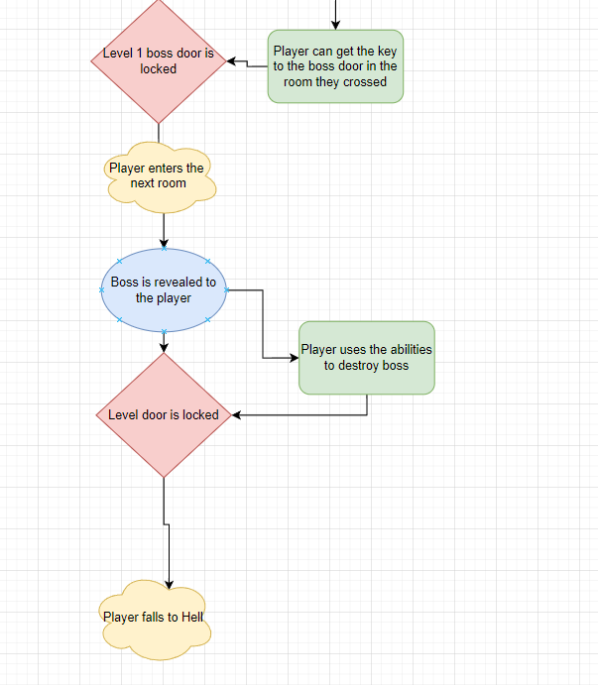

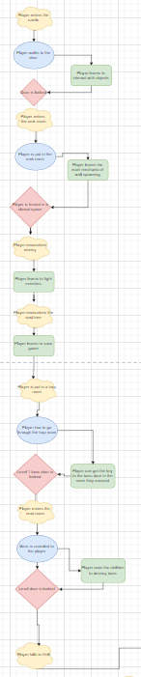

Hell Sequence

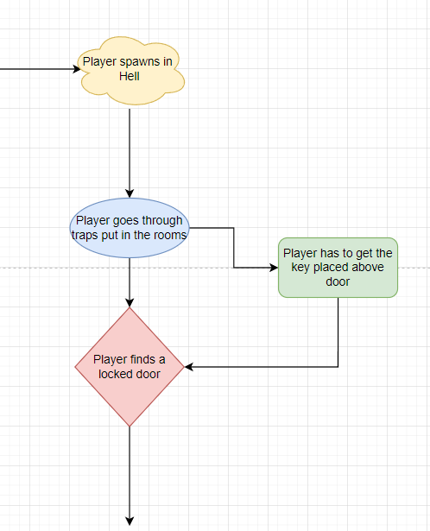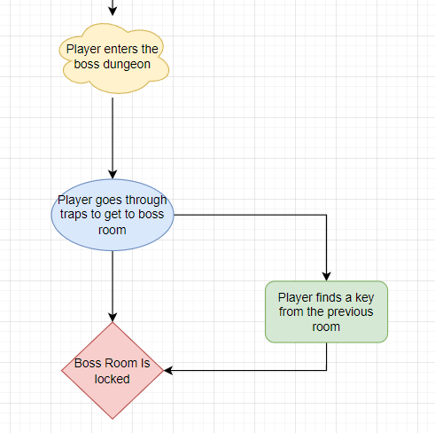

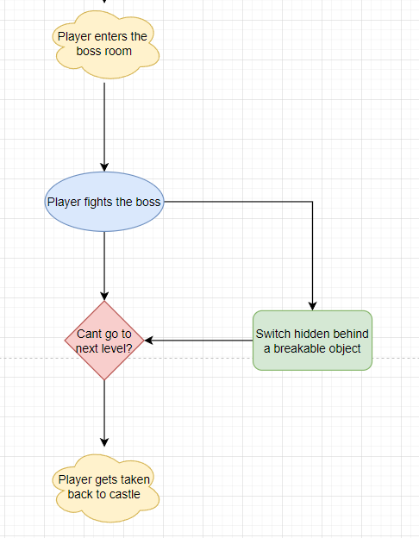

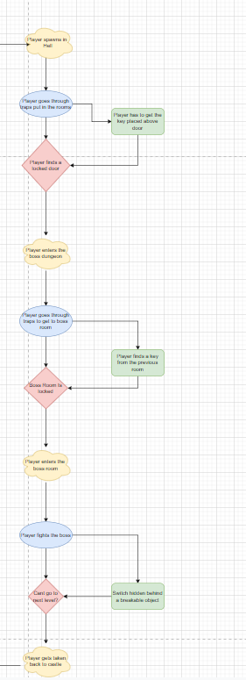

Throne Sequence

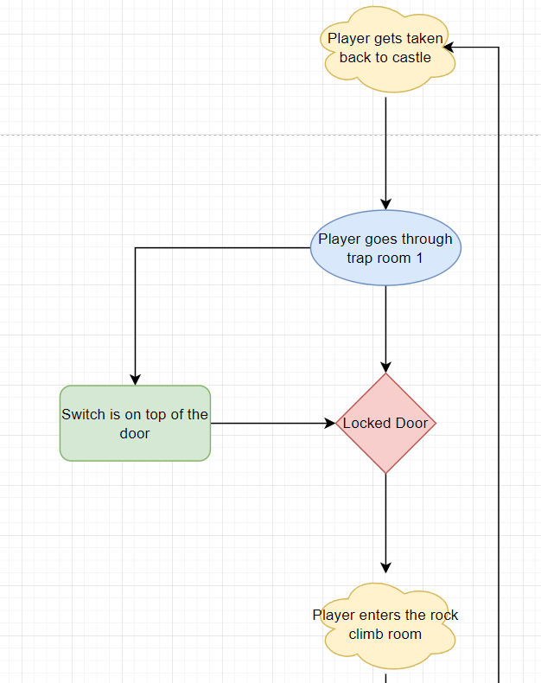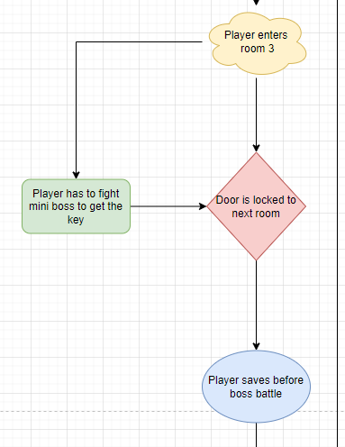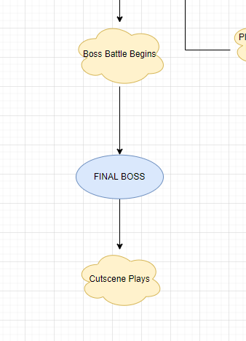

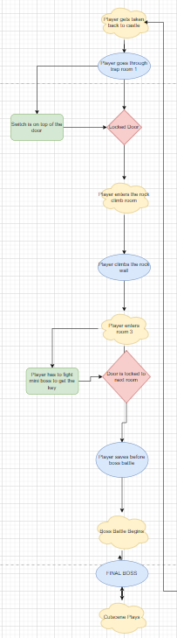

Full Sequence

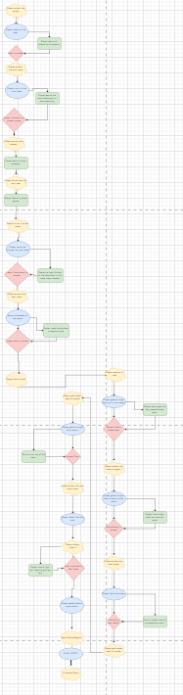

* Scripted Sequence Locations

The location for the scripted cutscene will be at the end of the level where the player must fight the final troll boss. This will trigger an event where the end level cut scene of the player going to the throne will be played

# Scripted Sequence documentation:

* Camera Shots and Timing

Shot one:

The player walks down to the throne as the camera stays static. This shot indicates that the player has beaten all its enemies and Dracul is in the throne room that place he wanted to reach from the start of the level. The track fades in to the next shot.

Shot Two:

Dracul sits on his throne showing that he is the rightful owner of the castle, and no one can overthrow him in his position. The camera pans back to show the throne room and the track fades out with the sitting animation playing

* Special FX

There won’t be any special effects used for the cutscene other than a volumetric fog to set a dense mood

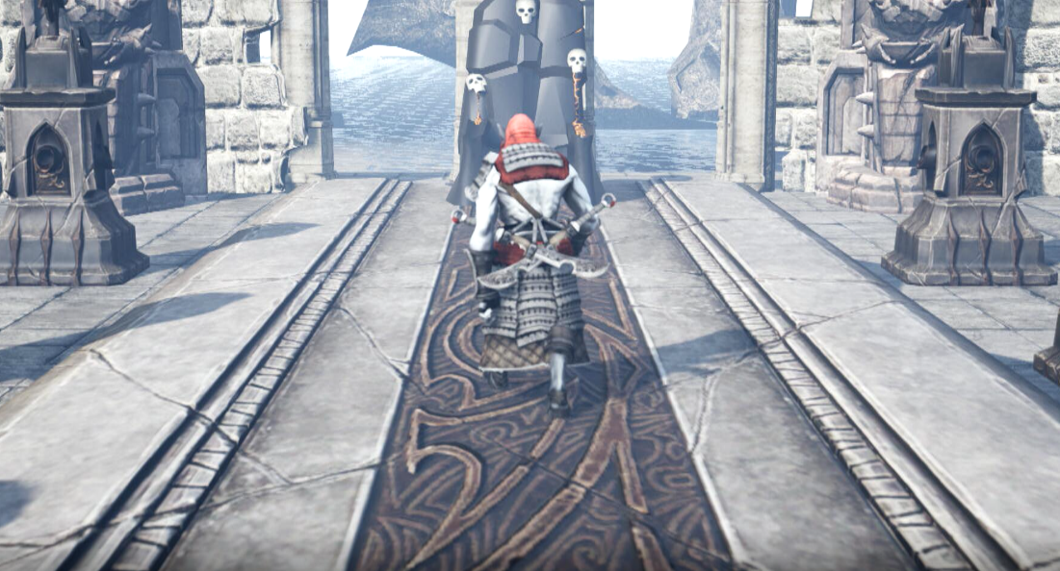

* Audio

Audio will be a non-copy right music of a king walking to the throne that I found on YouTube. There will be only the music playing over the background.

* Environment Animation

The environment will be static and the only moving components for the cutscene will be the player movement for the walk animation and the sit animation. I will be using a new level for my environment meshing.

* Character Animation

Character animations for the player character will be imported from Mixamo. The framework does not support the new animations so a new skeleton will have to be imported.

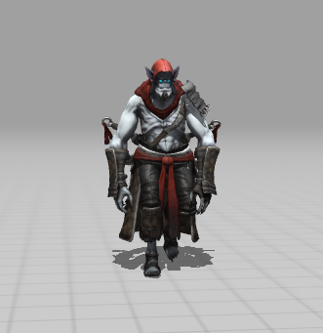

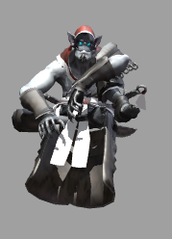

* UI Control

During the animation is being played for the cutscene the UI will be taken out of the frame so that the animations will be played properly.

* Asset List

Sitting Animation: [Sit Animation](https://www.mixamo.com/#/?page=1&query=sitting&type=Motion%2CMotionPack)

Walk animations: [Walk Animation](https://www.mixamo.com/#/?page=1&query=walking&type=Motion%2CMotionPack)

Non-Copy Right music: [Music](https://www.youtube.com/watch?v=MM3ocHb2VsI&ab_channel=RoyaltyFreeZone-EpicJourney)

# Player Characters, Controls and Abilities

* Player Controls and Map

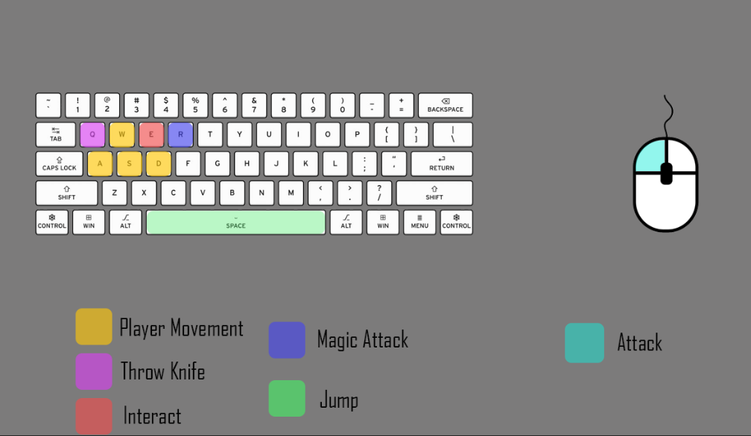

* Player Camera

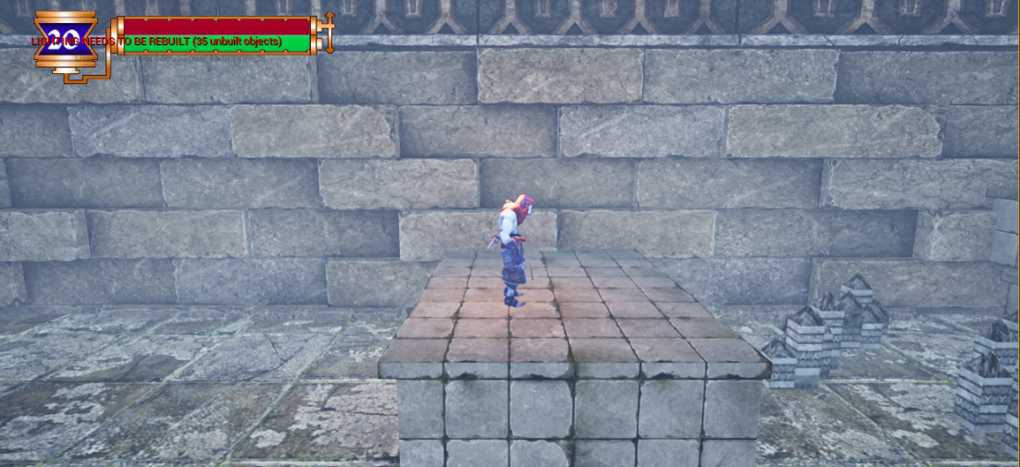

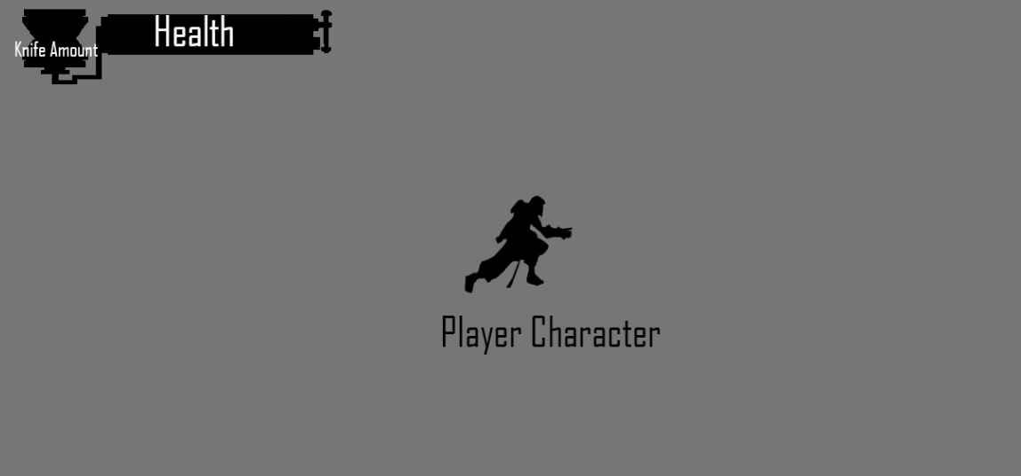

* Character/s background

The character Dracul is back from a century of roaming the earth endlessly only to return to see his home has been overrun by his enemies. We follow Dracul around the castle to retake his home.

* Character/s Mechanics

Knife Throw: -

Thow your knife to spawn a platform on a wall to get too hard-to-reach places. Thew knife travels thirty Unreal Units before exploding from overload. When the knifes hits a wall, it spawns a wall facing the direction opposite to the player.

Magic Throw: - Use your magic throw to stun enemies and get the higher ground. Upon deploying the magic spell, the spell travels 15 Unreal Units before exploding

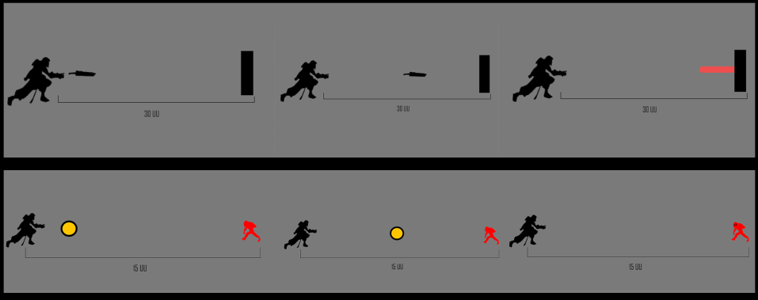

* Character/s Physics

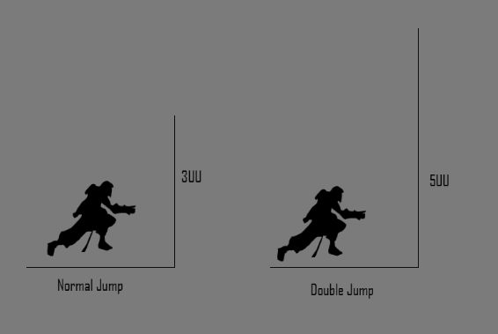

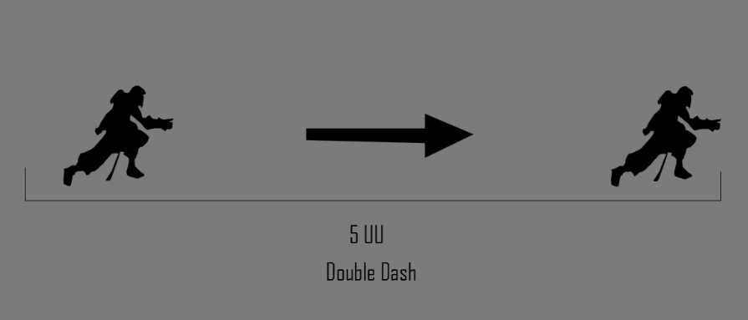

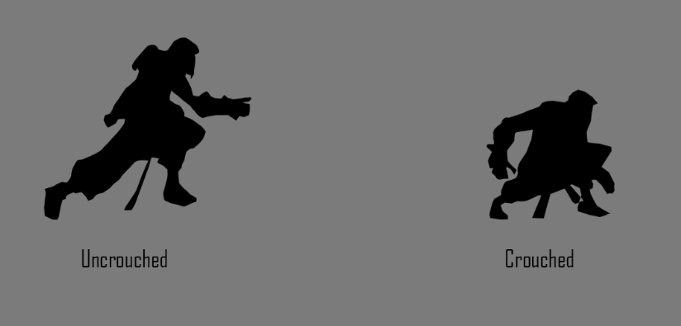

* Character/s statistics
  + Current Amount
  + Max Amount
* Character/s Weapon Loadout
  + The character will be using a whip as its primary weapon but can switch to a throw knife or its magic ability with does damage as well.
  + In total the player will have three weapons to use against enemies.

# Weapons and Pickups

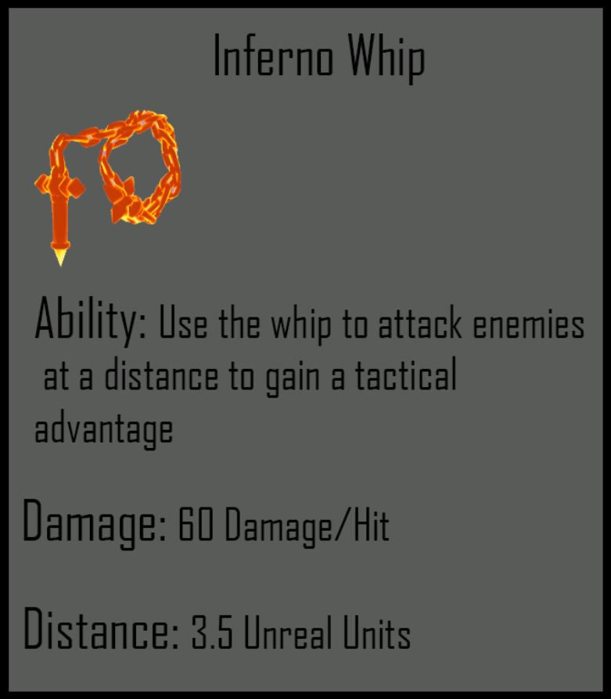

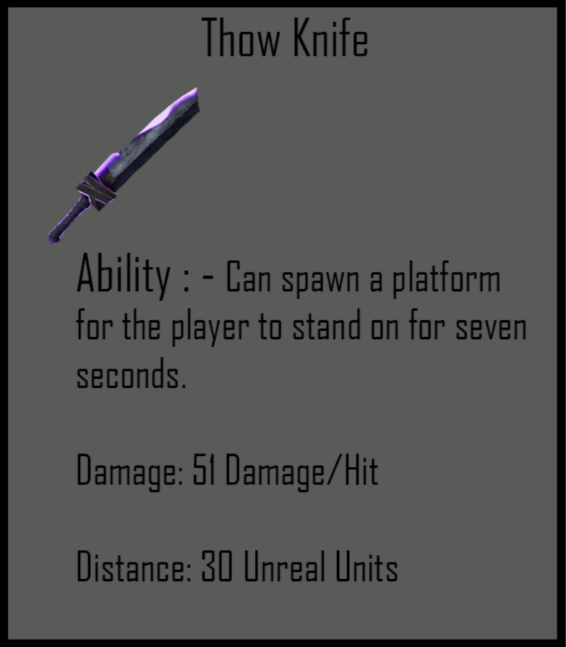

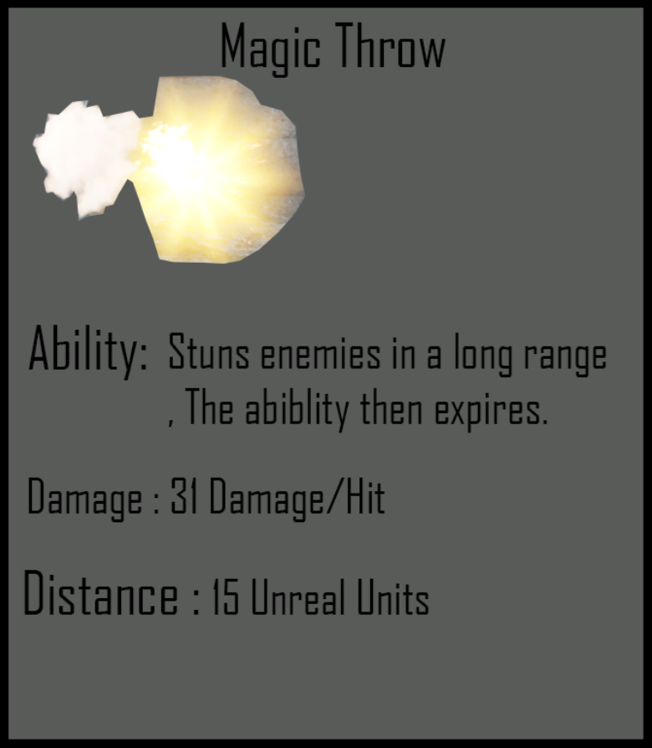

# Game Conditions

* How do you win?

The only win condition for the game is for the player to kill the end level boss and then an end level cutscene plays. The game then ends, and the menu pops up.

* How do you lose?

The way to lose is to get killed by one of the members of the villain league. The other way the player can die is to get hit by the traps set by the enemies.

* Can you die?

If the players' health hits zero, the character will die and then they will have to start from the last save point with the enemies

# Rewards and Progress

* Achievements based on player type such as collector, explorer, killer.

Players who enjoy the genre of Metroid Vania and explorer types will enjoy this game. The satisfaction of reaching the end goal or helping the player character to reach the end goal is an achievement the player get to feel when the cutscene comes un

* Key Drops / Usage

On being killed by the player, the enemy will drop a pickup for the player to use. I have set this pickup to be the knife pickup as I expect the player to not understand how to walls are spawned completely in the tutorial. The extra knives available provides a good margin of error. There are several HP drops that are available to the player and the player can use these to regain lost health before venturing further into the castle.

* Choke Points

There are multiple choke points in the level where the player must either mauver their way around a certain area, or they must kill bosses or enemies. The level has been set in a way such that the areas which requires the player to use their mechanic is also a choke point. The spacing between these choke points are clearly shown in the beats and pacing chart indicating the intensity of each section.

* Enemy Density

The placement of enemies is very sparse as the player will be focusing more on the movement aspect of the game and using the knife mechanic to complete the game fully. This allows the player to not get put in constant high intensity situation and reminds the player how to kill.

* Level Pacing with use of environment, enemies and pickups

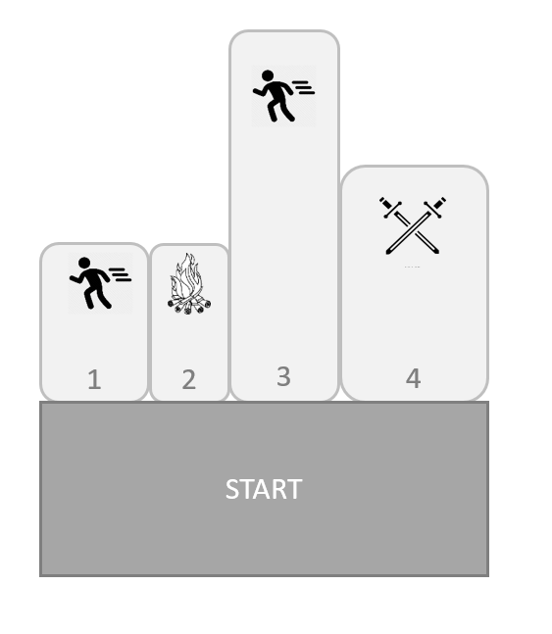

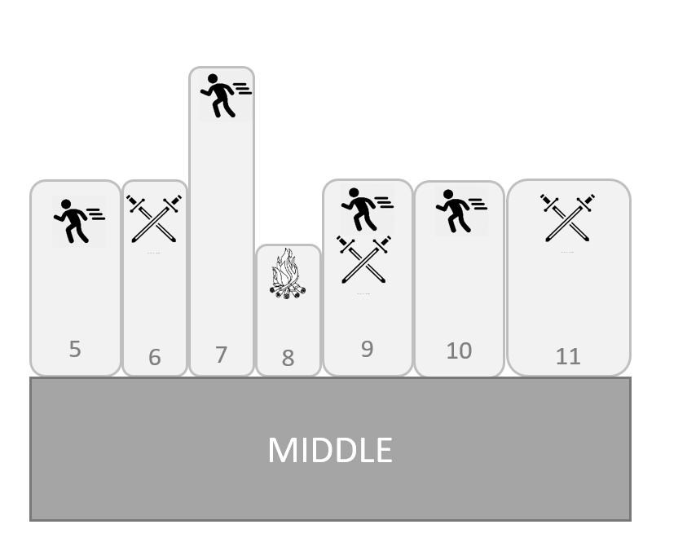

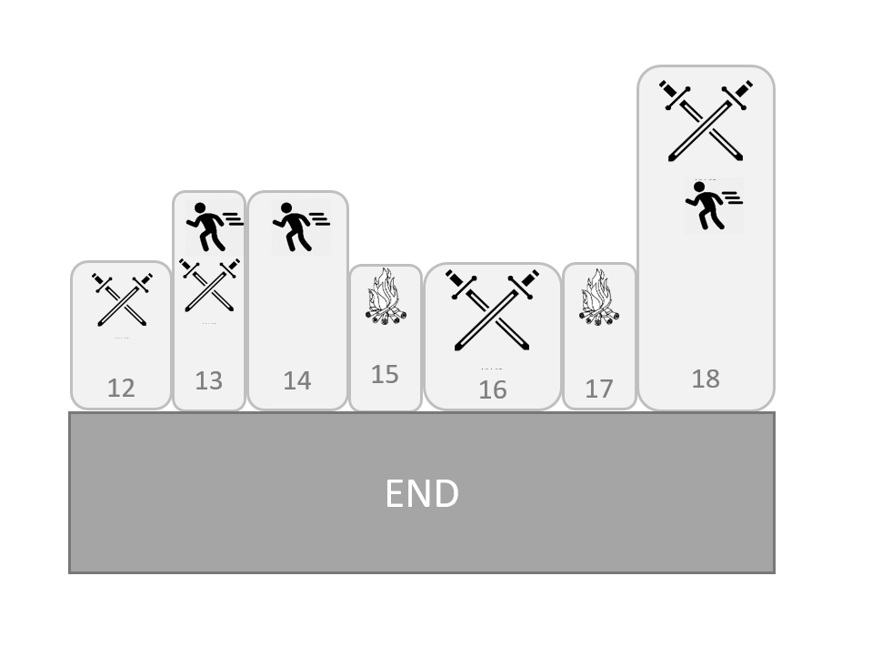

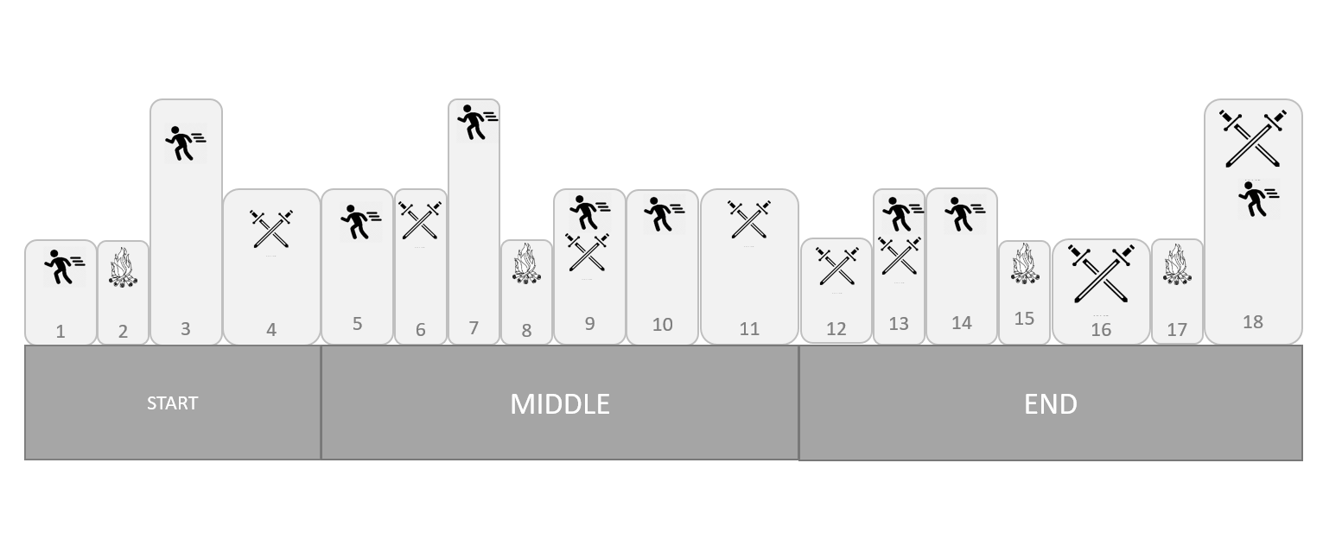

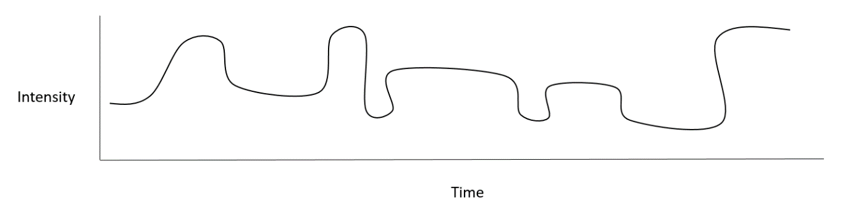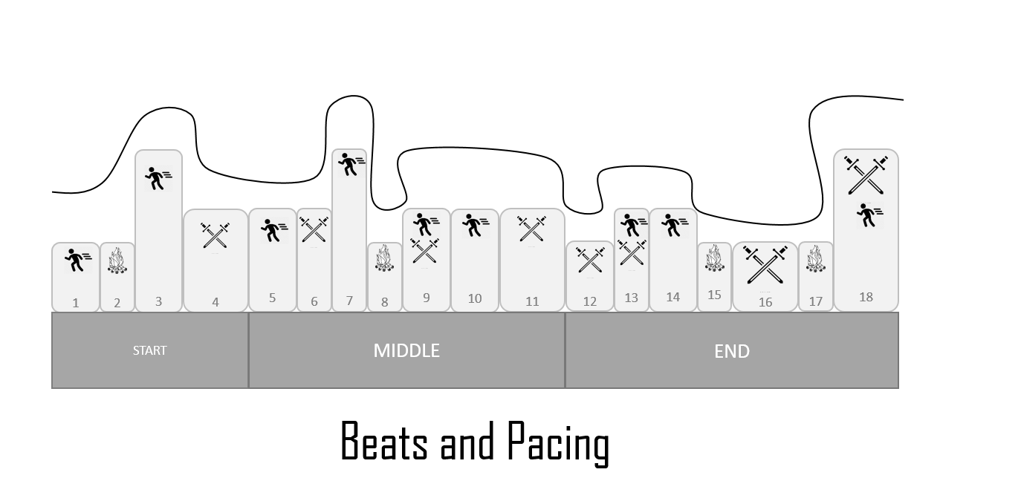

Enemy Design

